**On-premise changes for SaaS Provisioning:**

**Step1:** Create connectivity service at mta.yaml file

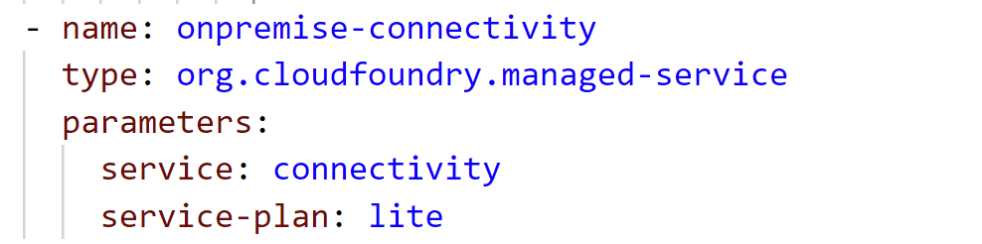

**Step2:** Add connectivity service in node module

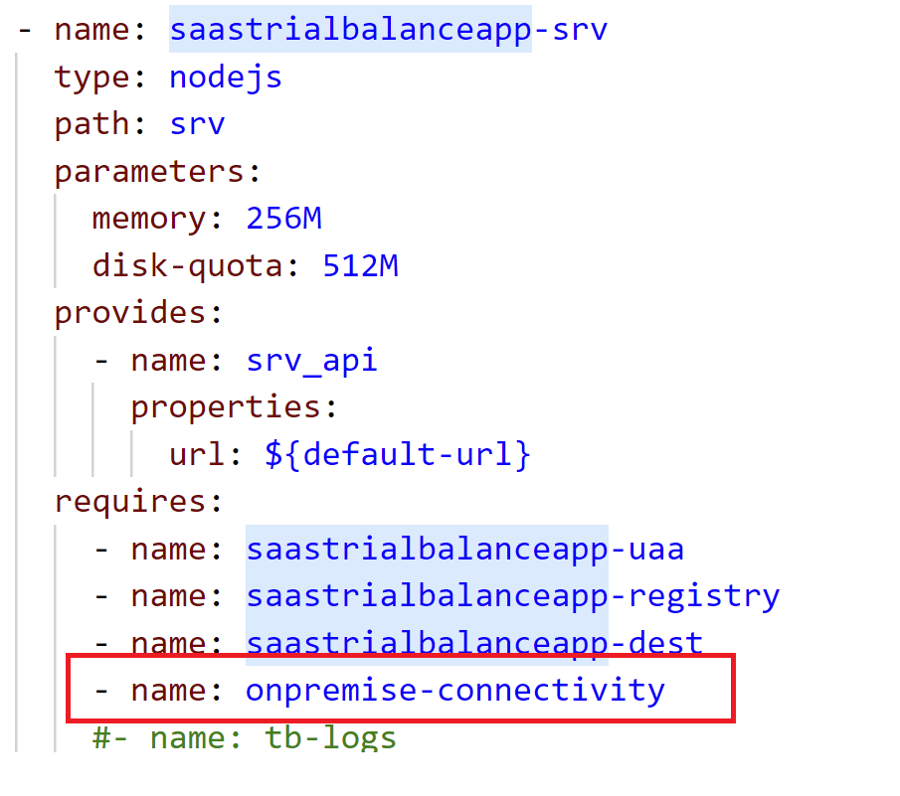

**Step3:** Get connectivity details from xsenv.getServices();

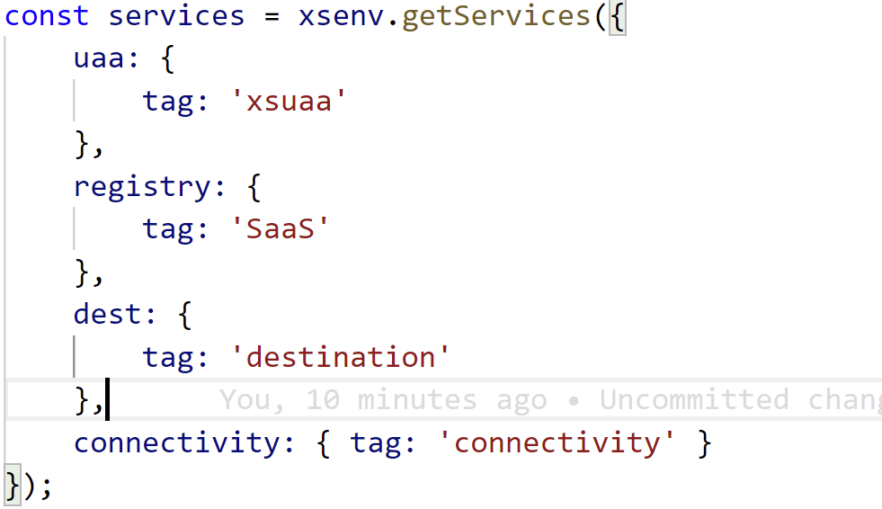

**Step4:** Add connectivity info in getDependencies()

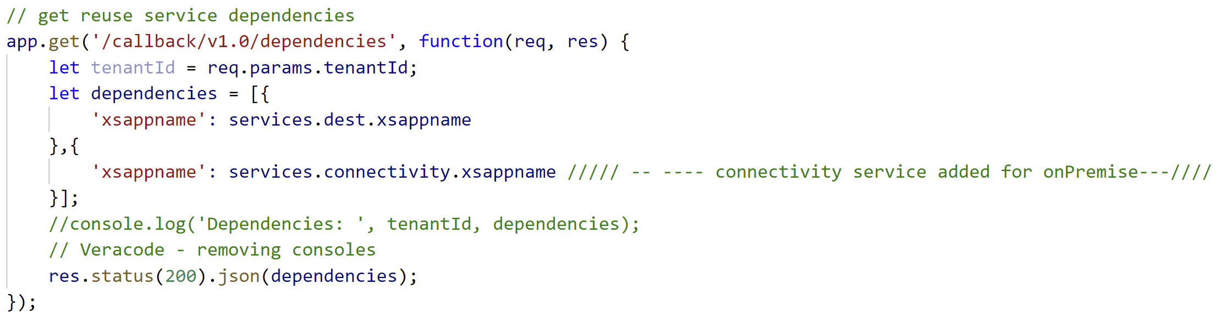

**Step5:** Get Connectivity info and assign it to one variable

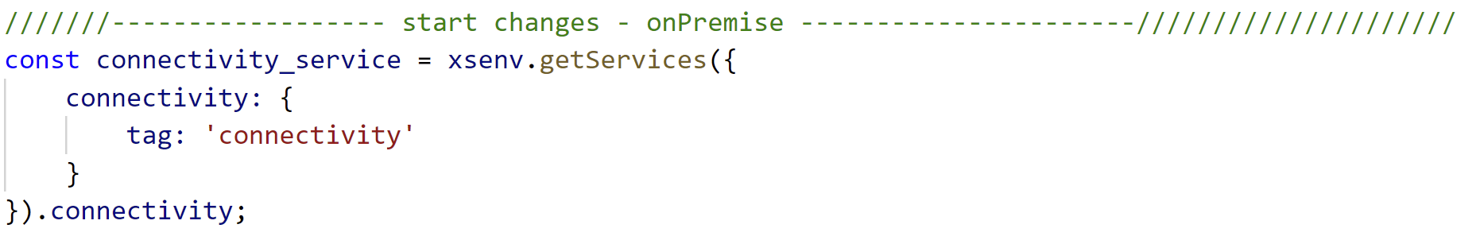

**Step6:** Get Connectivity JWT Token

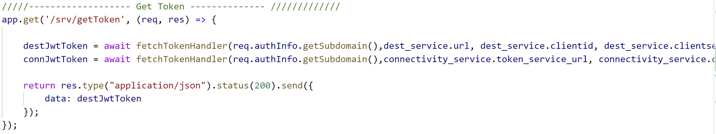

**Step7:** Set header for on-premise/cloud

